CREDIT CARD FRAUD DETECTION

Project submitted to the

SRM University – AP, Andhra Pradesh

for the partial fulfillment of the requirements to award the degree of

Bachelor of Technology

In

Computer Science and Engineering

School of Engineering and Sciences

Submitted by

MOUNICA NOTI |AP20110010575

MEGHANA AMARA|AP20110010577

TARUN VARDHAN|AP20110010297

JAYA BHAVANI|AP20110010567



SRM University–AP

Neerukonda, Mangalagiri, Guntur

Andhra Pradesh – 522 240

November,2023

# 

# 

# 

# 

# 

# 

# Table of Contents

ABSTRACT ii

INTRODUCTION iii

PROBLEM SURVEY iv

DATASET DESCRIPTION iv

PREPROCESSINGv

IMPLEMENTATIONvi

RESULTANT GRAPHvi

CODE x

CONCLUSION xiv

ABSTRACT:

Because fraudulent activity in electronic transactions is becoming more sophisticated, credit card fraud detection has become a vital area of financial security. In order to prevent consumers from being charged for goods they did not purchase, credit card issuers must be able to recognise fraudulent credit card transactions. Data science can be used to solve such issues.

Detection systems must combine real-time monitoring, adaptive models, and historical data analysis in order to continuously react to new fraud patterns and trends. It is a constant struggle to strike a balance between minimizing false positives and maintaining the precision required to identify possible fraud. In order to effectively combat credit card fraud in a constantly changing financial landscape, a multidisciplinary approach combining subject expertise, robust data management, and rapid technical solutions is required."

Dynamic and flexible detection systems are crucial; they must always change to anticipate emerging fraud trends and patterns. Finding a balance between reducing false positives and correctly detecting possible fraud is still a difficult task.

Fighting credit card fraud effectively requires a multifaceted strategy that combines financial sector knowledge, solid data management procedures, and flexible technology solutions. By ensuring the continuous integrity and security of electronic transactions, this protects consumers' and businesses' faith in financial systems."

INTRODUCTION:

Given the rise in the number of people utilizing credit cards on a daily basis, credit card firms ought to pay more attention to their clients' protection and safety. Global credit card usage was estimated to be 2.8 billion in 2019, with 70% of cardholders having at least one card.

Unauthorized and unwelcome use of an account by someone other than the account owner is referred to as "fraud" in credit card transactions. The conduct of such fraudulent practices should be researched to minimize it and guard against similar occurrences in the future. Necessary preventive actions can be adopted to halt this misuse. Put differently, credit card fraud occurs when someone uses someone else's credit card without the owner's knowledge or the authorities that issue credit cards being used for personal purposes.

Fraud detection is the process of keeping an eye on user populations' behaviors to gauge, identify, or steer clear of undesirable activity, which includes fraud, intrusion, and defaulting. This is a highly pertinent issue that has to be addressed by fields like data science and machine learning, since these fields can automate the answer. From the standpoint of learning, this issue is especially difficult because of its many characteristics, including class imbalance. The quantity of legitimate transactions greatly exceeds that of fraudulent ones. Furthermore, the statistical characteristics of the transaction patterns frequently alter over time.

There are two types of credit card theft. The first involves identity thieves opening a credit card account in your name. The second kind is utilized by identity thief uses an existing account that you created, and it’s usually done by stealing the information of the credit card

PROBLEM SURVEY:

It is known that there are many frauds going with credit cards and there are many techniques to identify those frauds like regression, decision tree, etc…in our project we perform decision tree, logistic regression, random forest using R programming language. Our main goal of this project is to know which of the above mentioned methods is more effective in detecting credit card frauds.

DATASET DESCRIPTION:

Credit card fraud detection dataset is taken from kaggle. This dataset shows the transactions that took place over a two-day period. Of the 284,807 transactions, 492 were fraudulent. Because of the extreme imbalance in the dataset, 0.172% of all transactions belong to the positive class (frauds).The main input variables are numbers that come from a PCA transformation. and the v1,v2,v3……….v28 are the features. Time and amount are the only features that are not transformed by the PCA. Class has two values 0 and 1 it takes value 1 in case of fraud and 0 otherwise. Given the class imbalance ratio, we recommend measuring the accuracy using the Area Under the Precision-Recall Curve (AUPRC). Confusion matrix accuracy is not meaningful for unbalanced classification.

Dataset:  


PREPROCESSING



sum(is.na(credit_card)) is performed to check whether there are any null values or duplicate values and there are no null values found. and the remaining dataset and its tuples are all clear. so no further preprocessing is required.





IMPLEMENTATION AND RESULT GRAPH:

Logistic regression:



Decision tree:

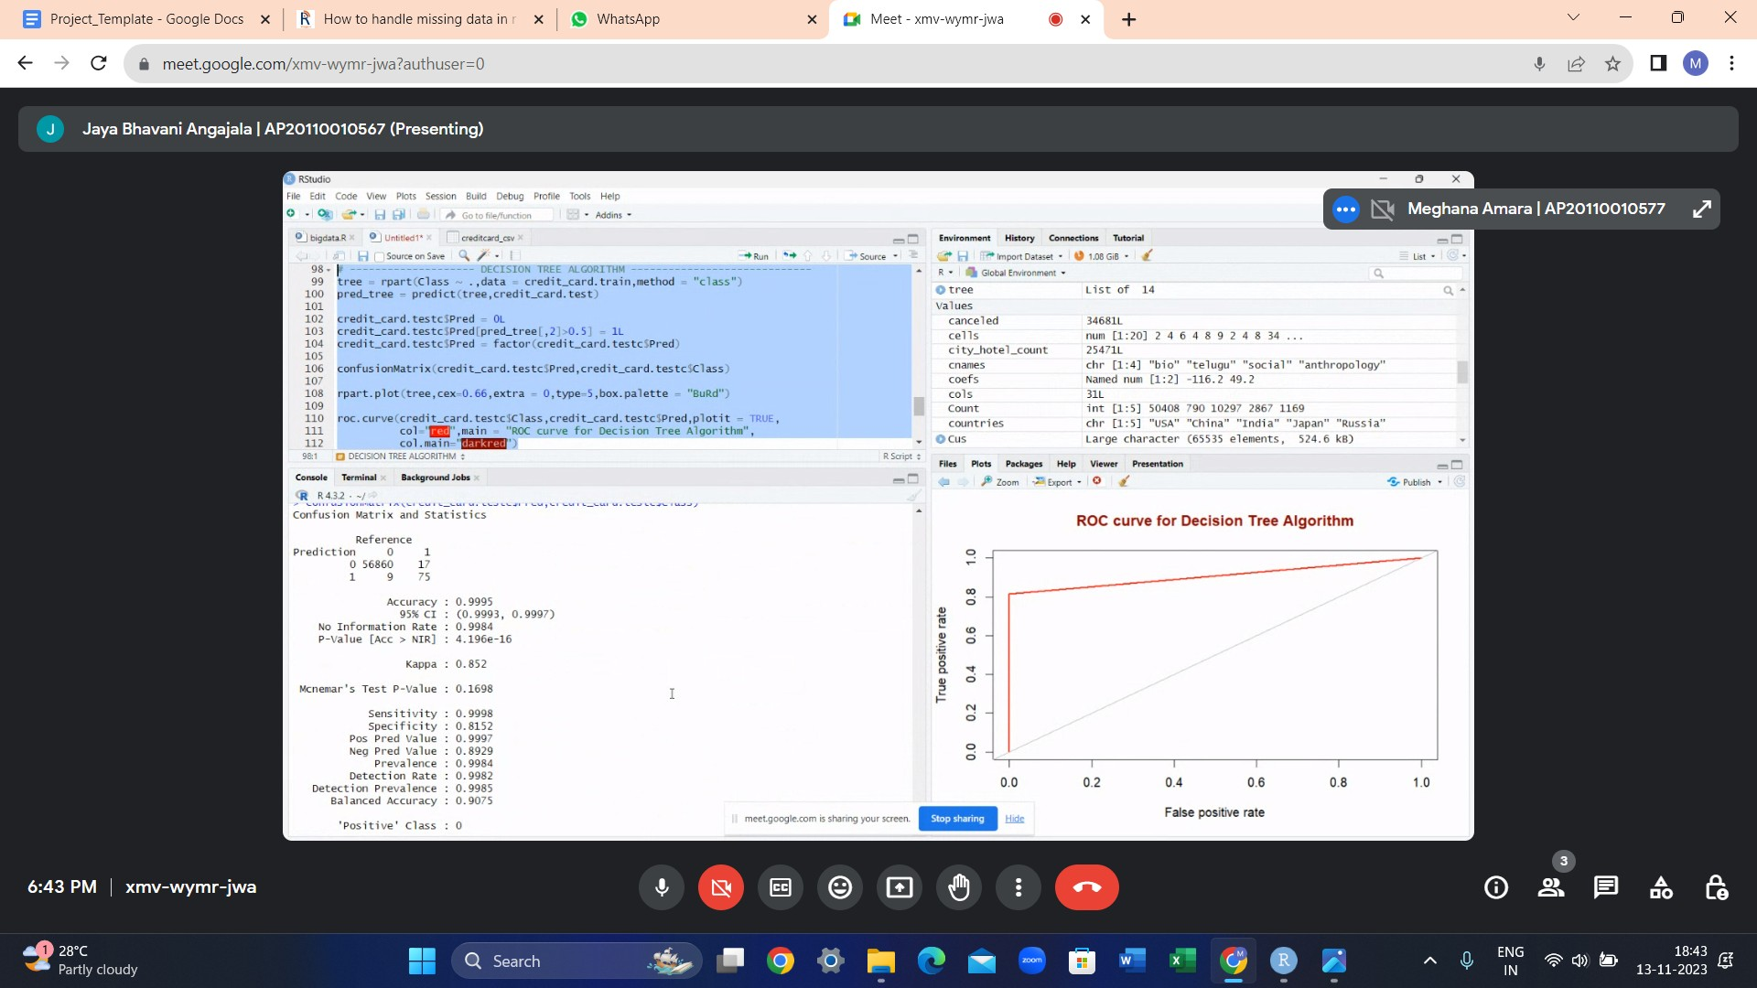

Random forest:



Data visualization:

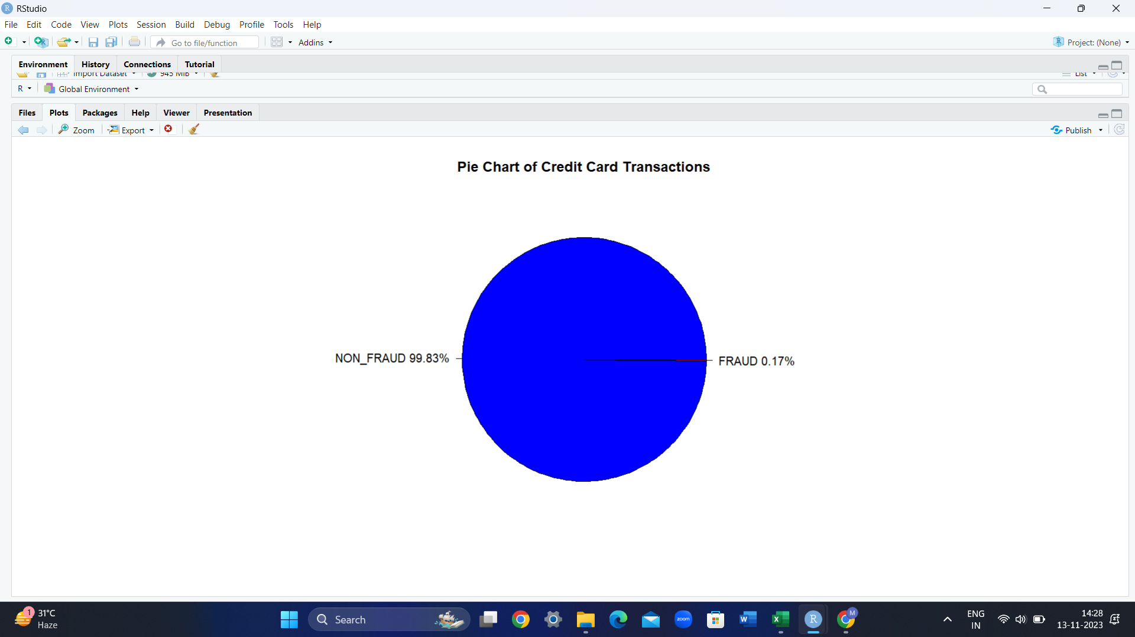



Code:

library(caret)

library(rpart)

library(dplyr)

library(ROSE)

library(randomForest)

library(rpart.plot)

library(readr)

creditcard_ <- read_csv("C:/Users/dell/Downloads/creditcard(!).csv")

View(creditcard_)

names(credit_card)

# --------------------- Printing the structure of data set ------------------

str(credit_card)

# --------------------- Printing 5-6 obs of the data set --------------------

head(credit_card)

# - Converting the Class to factor as it has 0 (non-frauds) and 1 (frauds) --

credit_card$Class = as.factor(credit_card$Class)

# -------------- Summarizing the count of the Frauds and Non-Frauds --------

summary(credit_card$Class)

# --------------------- Checking for any NA values -------------------------

sum(is.na(credit_card))

# -------------- Separating the frauds and non-frauds into new dfs ---------

credit_card.true = credit_card[credit_card$Class == 0,]

credit_card.false = credit_card[credit_card$Class == 1,]

# --------- Data Visualization on the basis of physically imp features -----

fig(12, 8)

common_theme <- theme(plot.title = element_text(hjust = 0.5, face = "bold"))

ggplot(data = creditcard, aes(x = factor(Class),

y = prop.table(stat(count)), fill = factor(Class),

label = scales::percent(prop.table(stat(count))))) +

geom_bar(position = "dodge") +

geom_text(stat = 'count',

position = position_dodge(.9),

vjust = -0.5,

size = 3) +

scale_x_discrete(labels = c("no fraud", "fraud"))+

scale_y_continuous(labels = scales::percent)+

labs(x = 'Class', y = 'Percentage') +

ggtitle("Distribution of class labels") +

common_theme

# --------- PIE CHART for comparing no.of frauds and non-frauds ------------

labels = c("NON_FRAUD","FRAUD")

labels = paste(labels,round(prop.table(table(credit_card$Class))*100,2))

labels = paste0(labels,"%")

pie(table(credit_card$Class),labels,col = c("blue","red"),

main = "Pie Chart of Credit Card Transactions")

# ---------------------- DATA SPLITTING -------------------------------------

rows = nrow(credit_card)

cols = ncol(credit_card)

set.seed(39)

credit_card = credit_card[sample(rows),1:cols]

ntr = as.integer(round(0.8*rows))

credit_card.train = credit_card[1:ntr,1:cols] # for train

credit_card.test = credit_card[(ntr+1):rows,-cols] # for test input

credit_card.testc = credit_card[(ntr+1):rows,cols] # for test data CLass

credit_card.testc = as.data.frame(credit_card.testc)

colnames(credit_card.testc)[1] = c("Class")

# ----------------------- LOGISTIC REGRESSION ------------------------------

glm_fit <- glm(Class ~ ., data = credit_card.train, family = 'binomial')

pred_glm <- predict(glm_fit,credit_card.test, type = 'response')

credit_card.testc$Pred = 0L

credit_card.testc$Pred[pred_glm>0.5] = 1L

credit_card.testc$Pred = factor(credit_card.testc$Pred)

confusionMatrix(credit_card.testc$Pred,credit_card.testc$Class)

roc.curve(credit_card.testc$Class,credit_card.testc$Pred,plotit = TRUE,

col="#D6604D",main = "ROC curve for Logistic Regression Algorithm",

col.main="#B2182B")

# -------------------- DECISION TREE ALGORITHM -----------------------------

tree = rpart(Class ~ .,data = credit_card.train,method = "class")

pred_tree = predict(tree,credit_card.test)

credit_card.testc$Pred = 0L

credit_card.testc$Pred[pred_tree[,2]>0.5] = 1L

credit_card.testc$Pred = factor(credit_card.testc$Pred)

confusionMatrix(credit_card.testc$Pred,credit_card.testc$Class)

rpart.plot(tree,cex=0.66,extra = 0,type=5,box.palette = "BuRd")

roc.curve(credit_card.testc$Class,credit_card.testc$Pred,plotit = TRUE,

col="red",main = "ROC curve for Decision Tree Algorithm",

col.main="darkred")

# -------------------- RANDOM FOREST ALGORITHM -----------------------------

samp = as.integer(0.49*ntr)

rF = randomForest(Class ~ . ,data =credit_card.train,ntree = 39,

samplesize = samp,maxnodes=44)

rF_pred = predict(rF,credit_card.test)

credit_card.testc$Pred = rF_pred

confusionMatrix(credit_card.testc$Pred,credit_card.testc$Class)

roc.curve(credit_card.testc$Class,credit_card.testc$Pred,plotit = TRUE,

col="green",main = "ROC curve for Random Forest Algorithm",

col.main="darkgreen")

CONCLUSION:

In this research, we have attempted to demonstrate various approaches to handling unbalanced datasets, such as the credit card fraud transaction dataset, where the proportion of fraudulent cases relative to normal transaction instances is low. Here, we have argued that accuracy is not a suitable metric to assess the performance of the model.The best score of 0.9996 was achieved using a random forest model while logistic regression models performed well too.It is likely that by further tuning the Random forest model parameters we can achieve even better performance